**Experiment # 04**

**OBJECTIVE:**

To become familiar with different sorting techniques in arrays

To become familiar with selection sort technique

**Theory:**

**Sorting Arrays:**

Sorting is a process of arranging the values of array in particular order. An array can be sorted in two orders;

**Ascending Order:**

In ascending order, the smallest value is stored in the first element of array; second smallest value is stored in the second element and so on. The largest value is stored in the last element.

Following array stored in ascending order.

Arr[6]={12,25,33,45,67,89}

**Descending Order:**

In Descending order, the largest value is stored in the first element of array; second largest value is stored in the second element and so on. The smallest value is stored in the last element.

Following array stored in Descending order.

Arr[6]={90,78,45,33,22,3}

**Selection sort:**

Selection sort is a technique that sort an array .it selects an element in the array and moves it to its proper position .

**Algorithm for Selection Sort**

* Find the minimum value in the list
* Swap it with the value in the first positon
* Sort the remainder of the list excluding the first value.

**Lab Tasks**:

**QNo:01 Develop a C++ code that sorts an array in descending order and array consists of five floating point values .**

**QN0.02 Compile and Execute the given code and display its output.**

#include<iostream.h>

#include<conio.h>

Void main()

{

Int arr[5]={55,77,88,95,99},i,j;

Cout<<”The Orignal values in Array “<<endl;

for( i=0;i<5;i++)

cout<<arr[i]<<” “;

for(i=0;i<4;i++)

{

min=i;

for(j=i+1;j<5;j++)

if(arr[j]<arr[min])

min=j;

if(min!=i)

{

temp=arr[i];

arr[i]=arr[min];

arr[min]=temp;

}

}

Cout<<endl<<”The Sorted Array\n”;

for(i=0;i<5;i++)

cout<<arr[i]<<” “;

getch();

}

**QUESTION NUMBER : 01:**

**Develop a C++ code that sorts an array in descending order and array consists of five floating point values .**

**PROGRAM:**

#include <iostream>

using namespace std;

int main()

{

int a[1000],i,j,temp,n;

cout<<" How much element enter in the array :";

cin>>n;

cout<<" Enter the number the element :";

for(i=0; i<n; i++)

{

cin>>a[i];

cout<<"\t";

}

for(i=0; i<n; i++)

{

for(j=i+1; j<n; j++)

{

if(a[i]>a[j])

{

temp=a[i];

a[i]=a[j];

a[j]=temp;

}

}

cout<<" After "<<i+1<<" itreation "<<endl;

for(int s=0; s<n; s++)

{

cout<<a[s]<<"\t"<<endl;

}

}

cout<<"\nThe sorting array in bubble is "<<endl;

for(i=0; i<n; i++)

cout<<a[i]<<"\t";

}

**OUTPUT:**

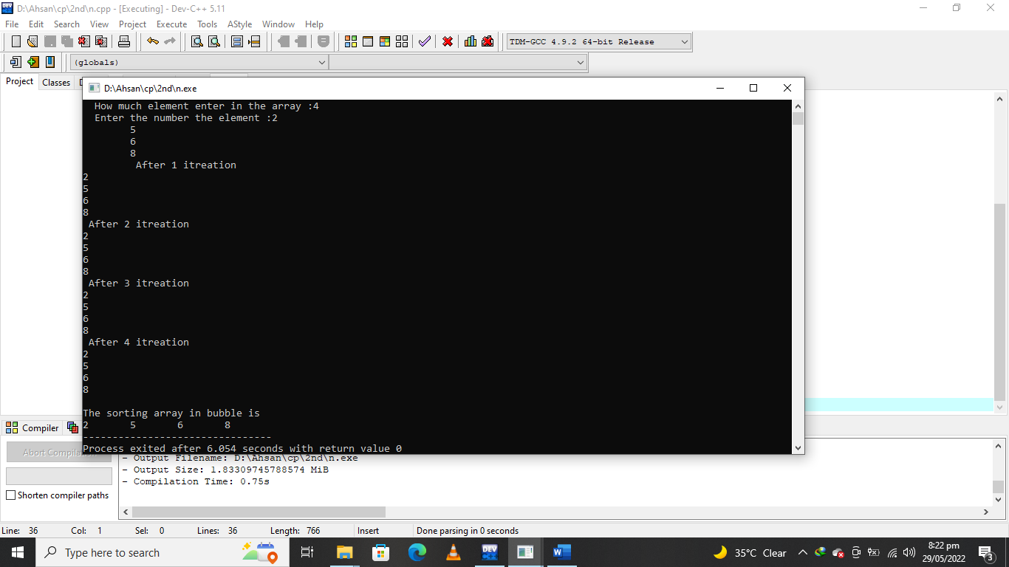

**QUESTION NUMBER : 02:**

**Compile and Execute the given code and display its output.**

**PROGRAM:**

#include <iostream>

#include<conio.h>

using namespace std;

int main()

{

int arr[5]={5,77,18,95,49},i,j;

int min=0,temp;

cout<<" The Orignal values in Array "<<endl;

for( i=0;i<5;i++)

cout<<arr[i]<<" ";

for(i=0;i<4;i++)

{

min=i;

for(j=i+1;j<5;j++)

if(arr[j]<arr[min])

min=j;

if(min!=i)

{

temp=arr[i];

arr[i]=arr[min];

arr[min]=temp;

}

}

cout<<endl<<" The Sorted Array\n";

for(i=0;i<5;i++)

cout<<arr[i]<<" ";

getch();

}

**OUTPUT:**

